**PRB4:** Task5: GMLC te Processing likha off korte pari na task 5 er konta eta? [2ta image ei off korte hobe]

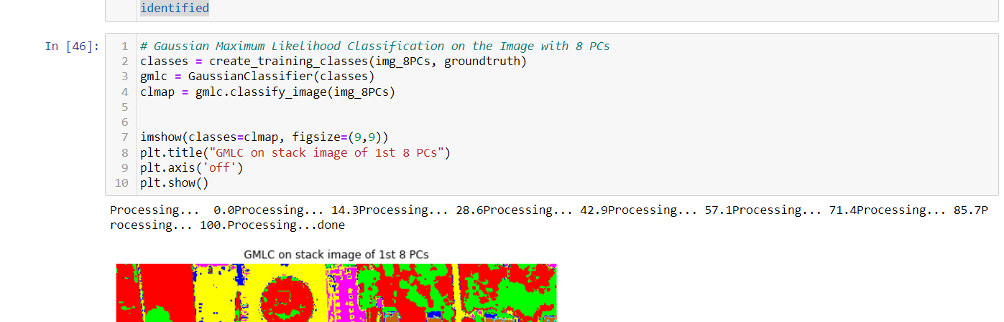

**PRB5:** How to plot 2 spectral images, side by side , ami GMLC er 2ta image,,pashe pashe boshaite chaisi.. [Chobir moto]

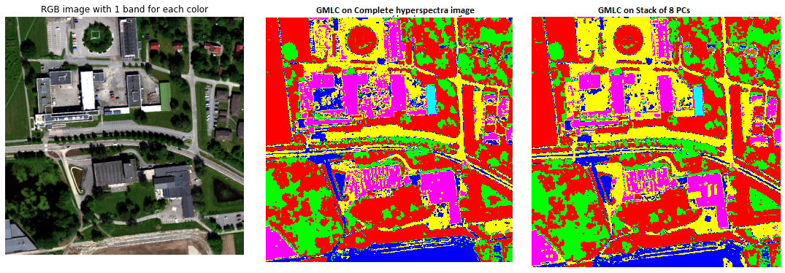

Dear Professor,  
  
I hope you are in good health. I have a few confusions related to the exam question. I have listed them below.

Questions:

1. **Exercise 1:** [Code] Should I run the sharpening using only the grey images Or should I include the RGB also? Because except for the Median filter, the rest of the filters only work on Grey images.
2. **Exercise 2(a) & 2(b):** Does the shadow removal have to be on the RGB image or the grey image? I was able to remove the shadow using masking. In that case, my task2(a) and task2(b) have the same answers. Does it need to be 2 separate answers/procedures?
3. **Exercise 3:**

1. **Task 3(a):** The default band is given in the “nmbu.hdr”. Should I use the default bands given or should I choose any bands within the spectrum range of each RGB colour according to my preference?

2. **Task 3(f):**

* “the class of vegetation”-- is it the class from the GMLC Or can I take a threshold of the NDVI image containing only the vegetation and then apply the edge detection?
* If I get the same result of overlay but using masking logic will it be okay or do I need to use the overlay from the ImageJ?

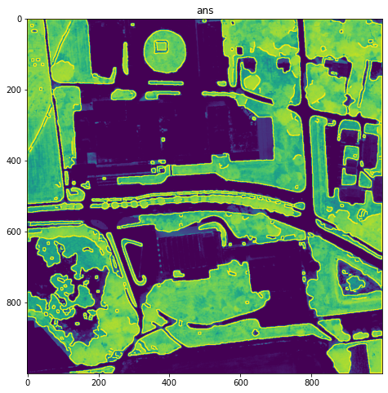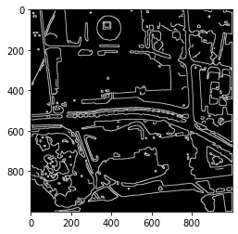

Hyperlinks in python

<https://www.folkstalk.com/tech/how-to-add-hyperlink-in-jupyter-notebook-with-code-examples/>

<https://sebastianraschka.com/Articles/2014_ipython_internal_links.html>

https://www.codegrepper.com/tpc/contents+links+python+jupyter

~~In this exercise, the goal was to sharpen a blurred image. The image was first transformed into an 8-bit image, then the “USM”-algorithm was applied to make that image sharper.~~

~~The «Unsharp masking» filter sharpens the image, by subtracting a smoothed version of image from the original, to then be added to the original image to enhance the edges there. In other words, the process follows 3 main steps.~~

~~STEP1:~~

**~~LOW-pass-filter~~**

~~The first step is to obtain a~~ **~~smoothed version of the original image.~~** ~~The original image consists of a lot of varying pixel values, and the aim of the smoothing process is to replace each pixel value by an average of surrounding pixels in a particular local frame-window of pixels. By moving this window-operator over the whole image, one can obtain a lowpass-filtered image. The lowpass-filtered image removes the high special frequency noise, by averaging the pixelvalues according to their surrounding, neighbourhood values.~~

~~In this case, the~~ **~~Gaussian Smoothing filter~~** ~~was used to obtain the smoothed image. The Gaussian Smoothing filter is a lowpass filter operator, which gives more weight to the central pixels than the neighbouring pixels.~~

~~In contrast to a more uniformly weighted average, such as a~~ **~~mean filter,~~** ~~giving more weight to the central pixels results in a gentler smoothed image and the edges are more preserved. In other words, the image is smoothed with less loss of information preserved on the edges.~~

~~STEP2:~~

~~The second step is to obtain a~~ **~~sharper image~~**~~.~~

~~The smoothing process is achieved by preserving the~~ **~~lower frequencies and filtering out the higher frequencies,~~** ~~the sharper edges. So, by subtracting this smoothed version from the original image, the result will consist of the~~ **~~higher frequencies and sharper edges which were “filtered out” in the smoothing process.~~**

~~STEP3:~~

~~So, it is possible to obtain a sharper image where the~~ **~~edges are intensified and more defined t~~**~~han in the original image. This is called a~~ **~~mask.~~**

~~The last step is to add this mask to the original image, resulting in a sharper image.~~ **~~The amount of sharpening is controlled by a weight factor.~~**